**SQL QUERIES**

**DATABASE msrps\_db**

**Table**

**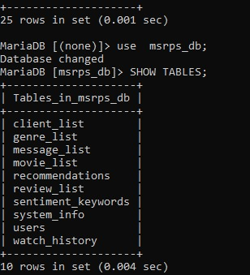**

1. **SELECT \* FROM client\_list;**

****

1. **Find all clients who have given reviews but have not rated any movie below 3:**

**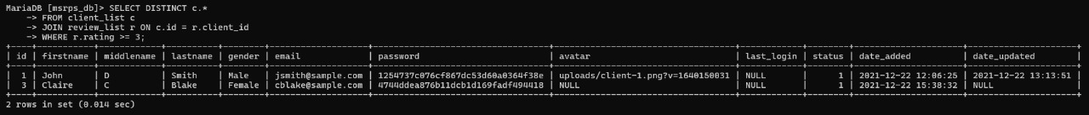**

1. **SELECT r.id AS review\_id, c.firstname, c.lastname, r.title, r.comment, r.rating FROM review\_list r JOIN client\_list c ON r.client\_id = c.id;**

**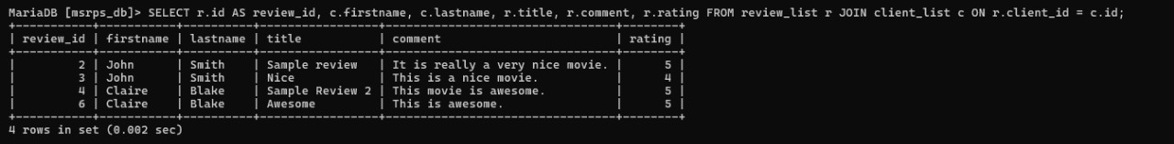**

1. **SELECT movie\_id, COUNT(\*) AS total\_reviews FROM review\_list GROUP BY movie\_id;**

**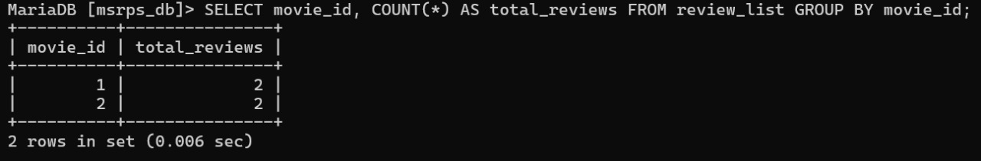**

1. **INSERT INTO movie\_list (id, title, genres, director, produced, writter, actors, description, release\_date) VALUES (3, 'Inception', '11,13', 'Christopher Nolan', 'Emma Thomas', 'Jonathan Nolan', 'Leonardo DiCaprio', 'A mind-bending thriller', '2010-07-16');**

**WhatsApp Image 2025-01-12 at 22.06.59_6941e473**

1. **UPDATE genre\_list SET description = 'Romantic Comedy' WHERE id = 9;**

**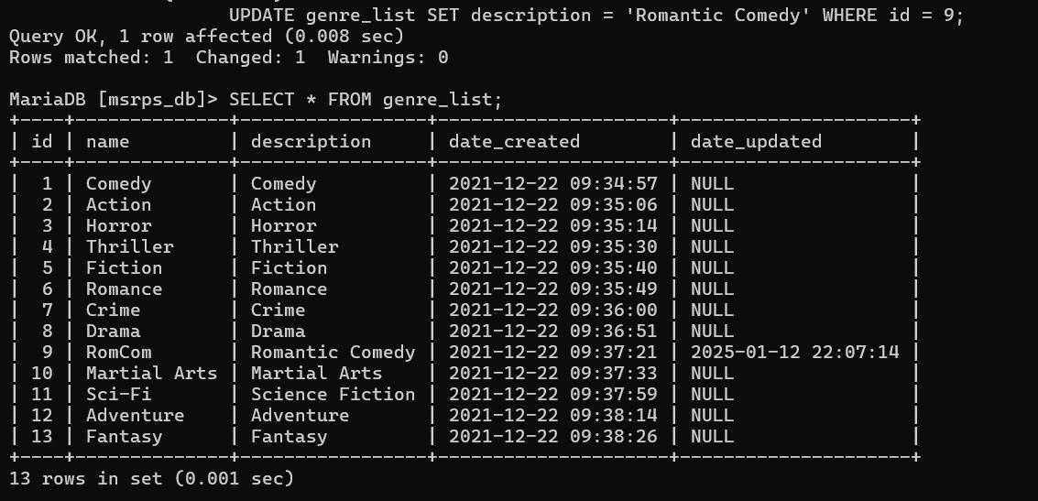**

1. **DELETE FROM sentiment\_keywords WHERE id = 17;**

**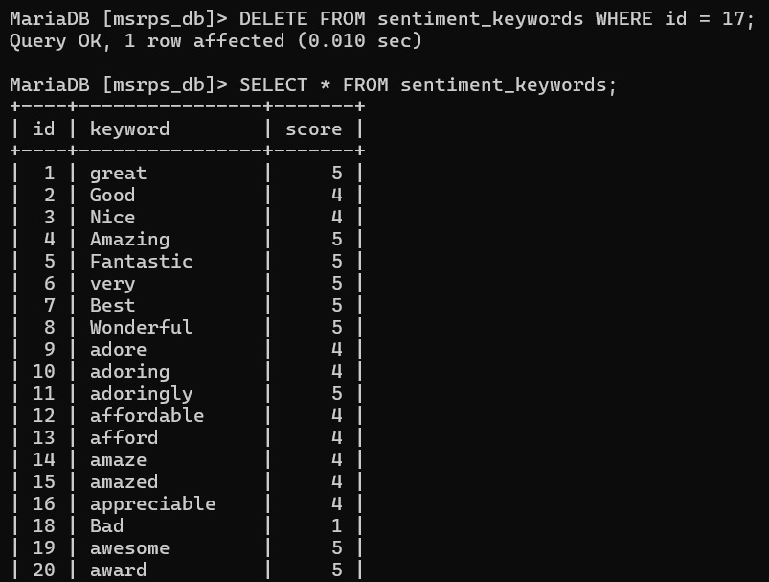**

1. **SELECT movie\_id, AVG(rating) AS avg\_rating FROM review\_list GROUP BY movie\_id;**

**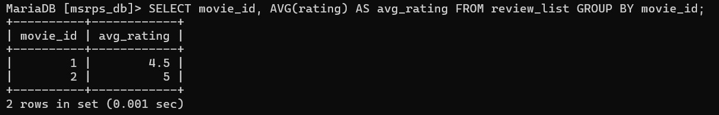**

1. **SELECT \* FROM client\_list WHERE gender = 'Female';**

****

1. **SELECT \* FROM movie\_list WHERE FIND\_IN\_SET('2', genres) OR FIND\_IN\_SET('4', genres);**

**WhatsApp Image 2025-01-12 at 22.12.53_b2334bf5**

1. **SELECT m.title FROM movie\_list m JOIN review\_list r ON m.id = r.movie\_id WHERE r.client\_id = 1;**

**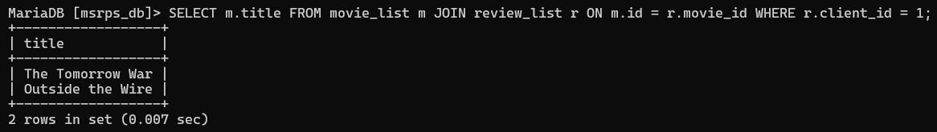**

1. **SELECT g.name AS genre, COUNT(m.id) AS movie\_count FROM genre\_list g JOIN movie\_list m ON FIND\_IN\_SET(g.id, m.genres) WHERE g.id = 11 GROUP BY g.name;**

****

1. **SELECT \* FROM client\_list WHERE status = 1;**

****

1. **SELECT m.title, MAX(r.rating) AS max\_rating FROM movie\_list m JOIN review\_list r ON m.id = r.movie\_id GROUP BY m.title ORDER BY max\_rating DESC;**

**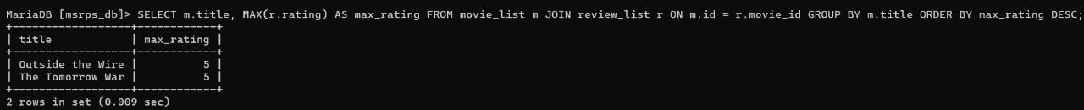**

1. **SELECT g.name AS genre\_name, COUNT(m.id) AS movie\_count FROM genre\_list g JOIN movie\_list m ON FIND\_IN\_SET(g.id, m.genres) GROUP BY g.id;**

**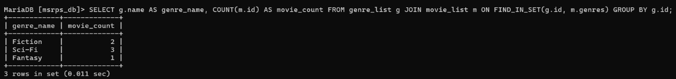**

1. **Retrieve the top 5 highest-rated movies along with their average rating:**

**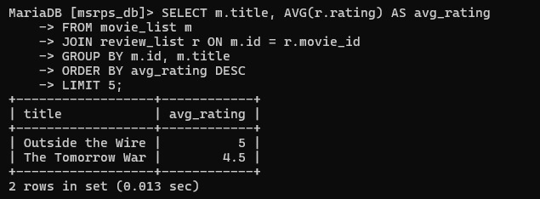**

1. **SELECT \* FROM client\_list WHERE id NOT IN (SELECT DISTINCT client\_id FROM review\_list);**

**WhatsApp Image 2025-01-12 at 22.18.28_718d0f78**

1. **SELECT \* FROM review\_list WHERE rating > 4;**

**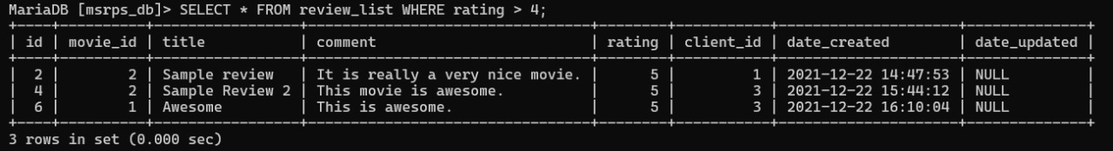**

1. **SELECT \* FROM movie\_list ORDER BY date\_created DESC LIMIT 1;**

****

1. **SELECT \* FROM movie\_list WHERE genres LIKE '%,%';**
2. **SELECT \* FROM movie\_list WHERE director LIKE '%Christopher Nolan%';**

****

1. **SELECT DISTINCT g.name FROM genre\_list g JOIN movie\_list m ON FIND\_IN\_SET(g.id, m.genres);**

**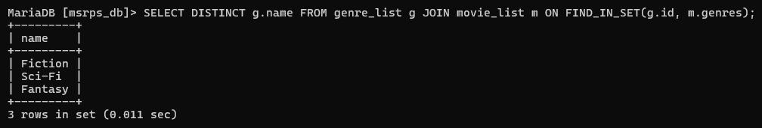**

1. **SELECT \* FROM movie\_list WHERE produced LIKE '%Emma Thomas%';**

****

1. **SELECT COUNT(\*) AS total\_genres FROM genre\_list;**

**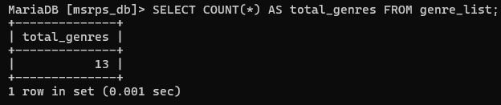**

1. **DELETE FROM client\_list WHERE status = 0;**

